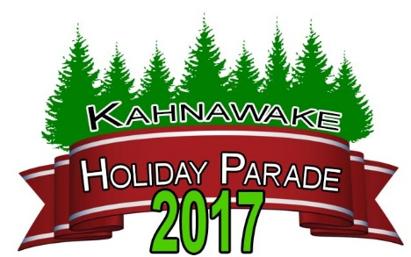

PARADE DATE rain or shine!: Sunday Dec. 17, 2017 - ENTRY DEADLINE: December 15th @ 4:00PM
Please Return Completed Form: To Kahnawake Shakotiia'takehnhas Community Services, 2nd floor Services Complex
Email: terryy@kscskahnawake.ca or Fax: 450-632-5116 entries will be confirmed by email or by telephone, (preferably email)
Contact Information This is an alcohol & drug free family event!

Name or Organization:

Address:

Contact Person:

Email Address:

Phone (daytime):
FREE Float Parade Entry - Organization Type
Phone (evening):

Business
Free

Individual
Free

Community Organization
Free

FREE Parade Entry - Type

Band Equestrian Float
Vehicle Walking Entry Other:

Your Parade Entry - Length - It is very important to be as accurate as possible with the entry length for the staging area

0-10 Feet 11-20 Feet 21-30 Feet
31-40 Feet 41-50 Feet Other:

Float entry - Description

Please note that your entry should not toss items into the crowd however we encourage entries

to include MUSIC!

Step by Step's float will have the official parade Santa Claus so please do not include

a Santa in your float.

We are strongly encouraging giving out of healthy treats (not candy) from your float

Special Requests:

I/We, the undersigned, indemnify and save harmless, the community of Kahnawake, the parade organizers, officials and participating organizations from and against any and all claims for personal injury or property damage or liabilities arising from
participation in, going to, during and dispersing from the Parade.

Date:
Signature:

